Division of Emergency Medicine
800 Commissioners Rd East • London, Ontario • N6A 5W9 • Canada
Telephone: (519) 685-8500 ext 76089 • Fax: (519) 667-6769

PARTICIPANTS NEEDED FOR RESEARCH STUDY EXAMINING
3D PRINTED PULSE OXIMETER PROTOTYPE

A pulse oximeter is a sensor device placed on the finger to measure oxygen levels in the blood.

We are looking for healthy, non-smoking adult volunteers over the age of 18 to take part in a study to calibrate and validate a newly designed, 3D printed pulse oximeter.

If you are interested and agree to participate you would be asked to: have an arterial catheter inserted into your wrist to measure the oxygen levels in your blood samples; have the experimental, 3D printed pulse oximeter and a control oximeter placed on your fingers; wear a breathing mask to deliver a mix of nitrogen and oxygen at a progressively different ratios under careful monitoring by an experienced emergency physician.

Your ONE TIME participation will take 2-3 hours of your time. You will not be compensated for your participation in this study.

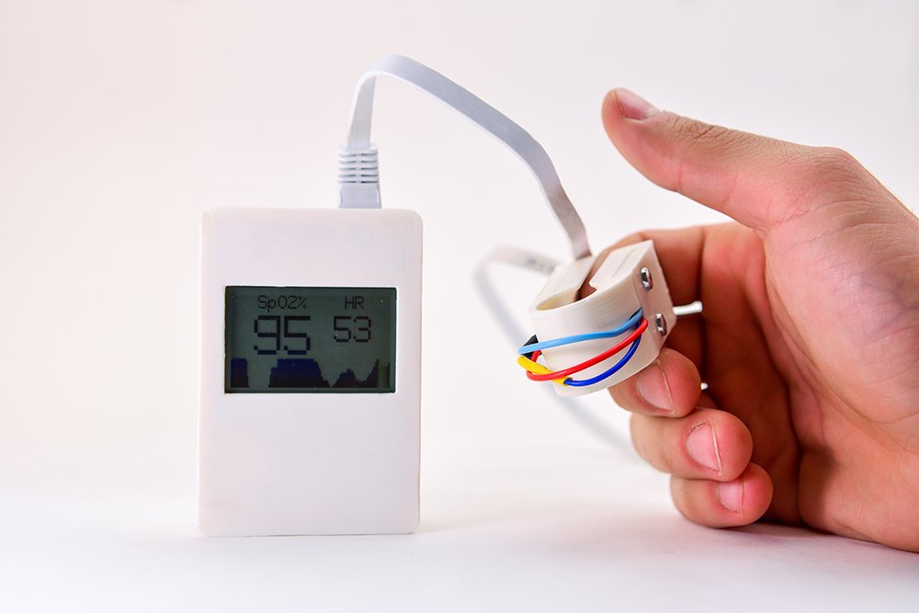
If you are interested in participating, please e-mail Dr. Tarek Loubani (tlouban@uwo.ca) with any questions or for more information.

